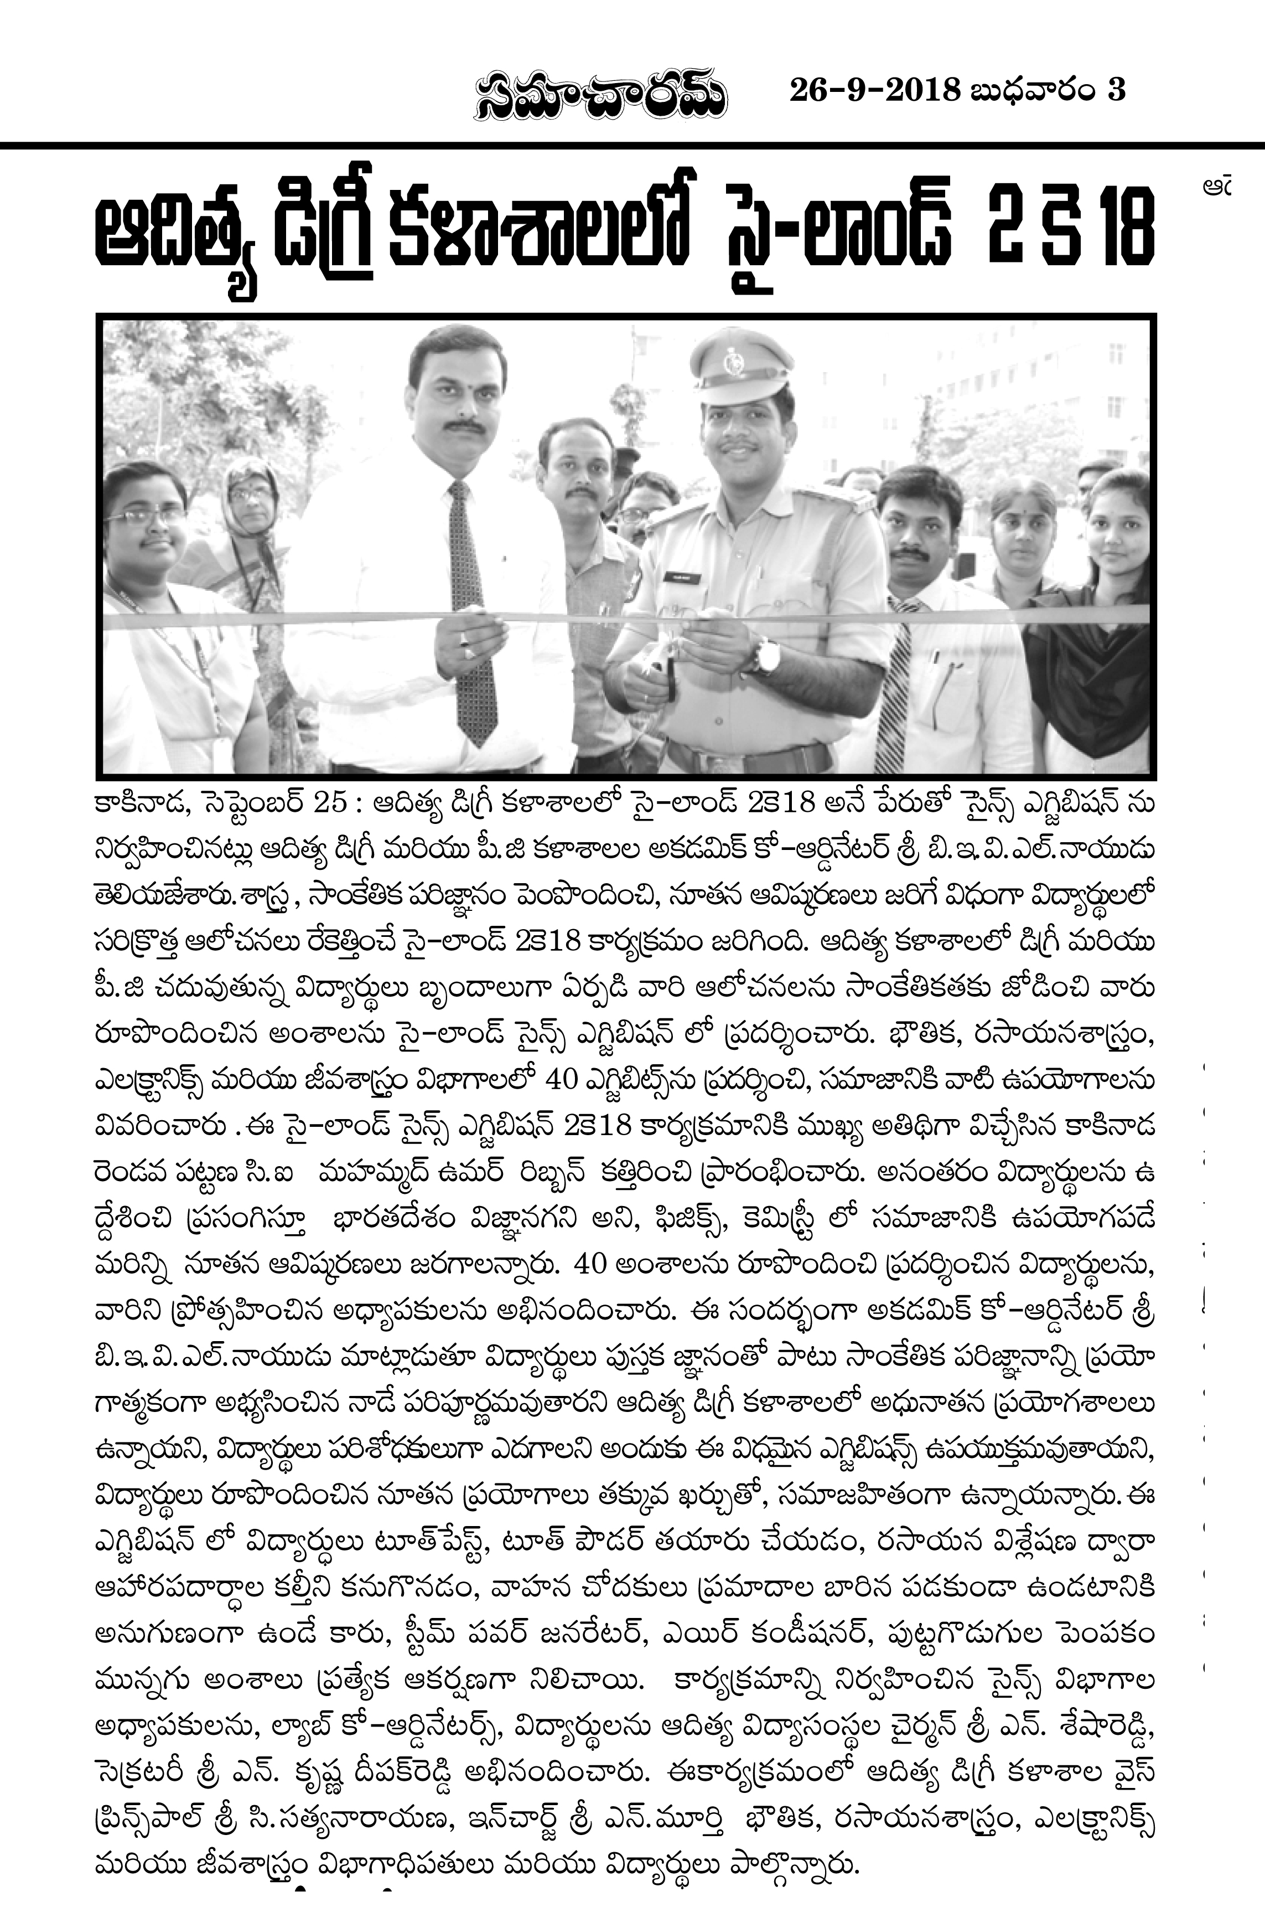 | 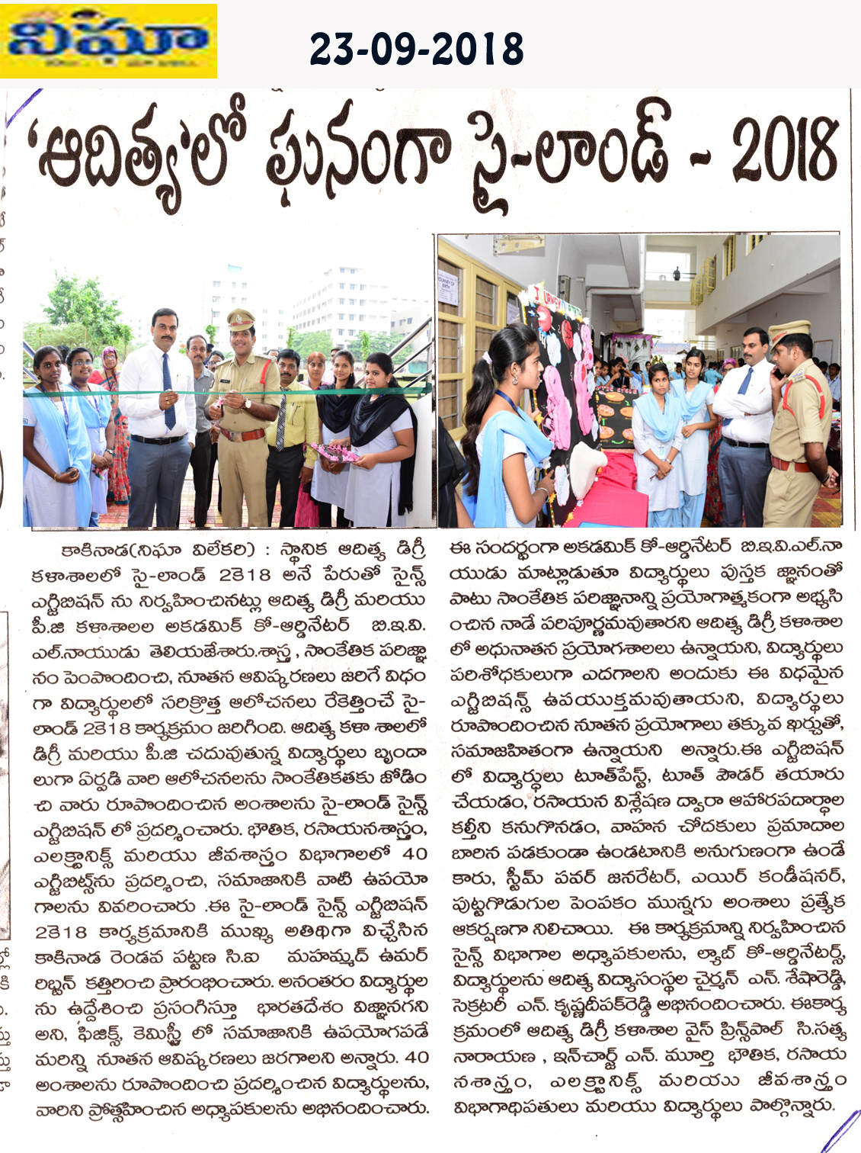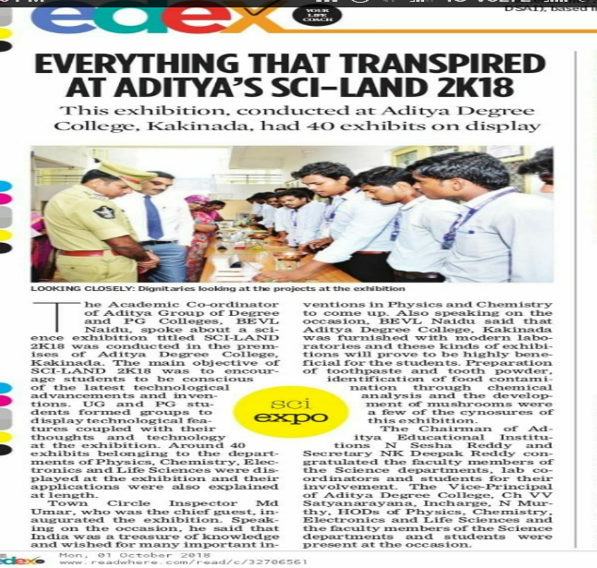
ADITYA DEGREE COLLEGE, KAKINADA
SCI - LAND 2K18
LIST OF STUDENTS WHO WON PRIZES
S.NO | NAME OF THE STUDENT | GROUP | DEPARTMENT | PROJECT | TOTAL SCORE | PRIZE | GUIDE
1 | P.KRISHNA SAI | II MPC-1 | PHYSICS | COOLER | 29 | I | OWN
2 | BALA BHANU CHANDAR | II MPC-1
3 | P.N.D.V.PRASAD | II MPC-1
4 | T.AMRUTH SREE | II MPCS-1 |  | HOLOGRAM | 29 | II | ABK MURTHY
5 | R.RAJESWARI | II MPCS-1
6 | G.VYSHNAVI DEVI | II MPCS-1
7 | V. ARAVIND | II MECS-2 | ELECTRONICS | OBSTACLE  DETECTION CAR | 30 | I | KASI & PRADEEP
8 | D. GANESH CHOWDARY | II MECS-2
9 | S. VINAY KUMAR | II MECS-2
10 | M.KRISHNA VENKAT RAO | II MECS-2
11 | M.L.N.V. SOMESWARA RAO | II MECS-1 |  | Hi-Fi CLASS ROOM | 29 | II | OWN
12 | HARPANAHALLI SRI VIDYA SAGAR | III BBC | U.G.  CHEMISTRY | STEAM POWER  GENERATOR | 27 | I | K. DIVYA
13 | MATTAPARTHI RUDRA RAJU | III BBC
14 | GEDDAM BHANU TEJ | III MBC
15 | PITTA ABHI SHEK | III MBC
16 | HARSHA VARDHAN VARMA BUDDHARAJU | I MPC 2 |  | LIQUID CRYSTALS | 25 | II | ANUSHA
17 | YARRA REDDY AMBATI | I MPC 2
18 | VENKATA SHANMUKA PAVAN VASUDEVA SAMPARA | I MPC 2
19 | DURGA SINHA | III MBC | U.G.  LIFE SCIENCE | JOURNEY OF BIRTH | 29 | I | R.LALITHA
20 | APOORVA NAMBURI | III MBC
21 | BOKKA GAYATRI MADHU | III BBC
22 | VEERA VENKATA AMRITHA YISARAPU | III BBC
23 | SATYAKRISHNA PRABHU BOBBILI | III MBC |  | MUSHROOM CULTURE | 28 | II | N. BHAVANI
24 | DHANVANTH NAIDU ADABALA | III BBC
25 | SRINIVAS VARMA CHINTA | III BBC
26 | SIVA SURESH NAIDU Y. | III BBC
27 | S.LALITHAMBIKA | I MSC(MB) | P.G.  LIFE SCIENCE | STEM CELL AND  CORD BLOOD | 28 | I | P.SUDHAKAR
28 | N. MOUNIKA | I MSC(MB)
29 | V.LIKITHA | I MSC(MB)
30 | GUNDA MAHESWARI | I MSC(BC) |  | BLOOD CIRCULATION | 26 | II | D.LALITHA
31 | KOLLA BATHULA PRASUNA | I MSC(BC)
32 | NARLA SWATHI ANVESI | I MSC(BC)
33 | M.R.S SANDEEP KUMAR | I MSC | PG.  CHEMISTRY | FOOD ADULTERATION | 29 | I | P. KASI VISWANATH
34 | Y. SATISH | I MSC
35 | K. RAMAN JANEYULU | I MSC
36 | S.V.V.S. GANGADHAR | I MSC
37 | G. SUBRAHMANYAM | I MSC |  | PREPARATION OF  TOOTH PASTE | 26 | II | P. KASI VISWANATH
38 | B. VIJAY | I MSC
39 | K SUBBA RAO | I MSC
40 | V. SURESH | I MSC
41 | M. MANIKANTA | I MSC

Sl.No | Name | Coordinators
1 | Sri. N B C N Murthy | Project lead Coordinator
2 | Sri K.suresh kumar  Assistant Professor  Chemistry & Life Sciences | Project coordinator
3 | .Smt K kumar  Assistant Professor Computer Science | Project coordinator
4 | Sri. V. Srinivas rao  Assistant professor  Electronics | Project coordinator
5 | Dr. Sreenu Barla  Associate professor  Dept. of Lifescience  Aditya Degree College | Project coordinator

CIRCULAR

All the U.G, P.G Students & Staff members please be informed that a SCI-LAND will be conducted on 22-09-2018 to 23-09-2018, from 9.00 AM to 5.00 PM, at our college ground, at Aditya Degree College, Kakinada.

Coordinator

